EX NO : 6 DEMONSTRATE LINUX PRIVILEGE ESCALATION DATE : 2.4.2025 ROLL NO : 231901027

AIM:

Learn the fundamentals of Linux privilege escalation. From enumeration to exploitation, get hands-on with over 8 different privilege escalation techniques.

TASK 2 : WHAT IS PRIVILEGE ESCALATION?

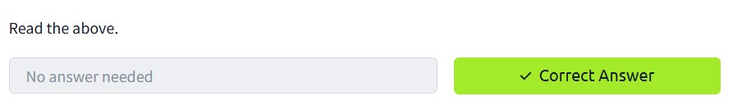

TASK 3 : ENUMERATION

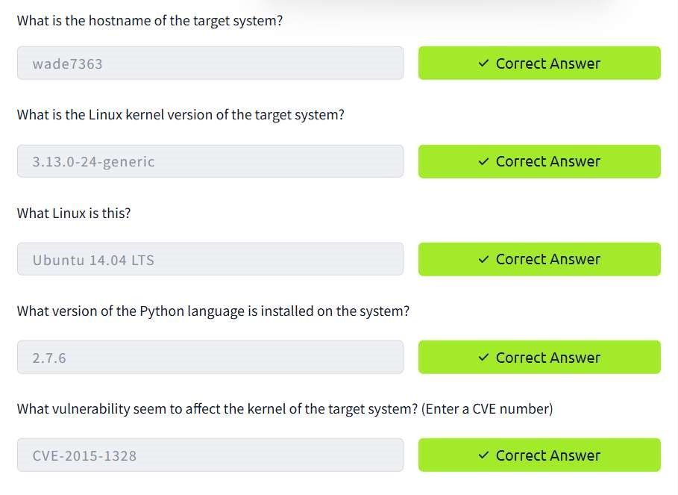

TASK 4 : AUTOMATED ENUMERATION TOOLS

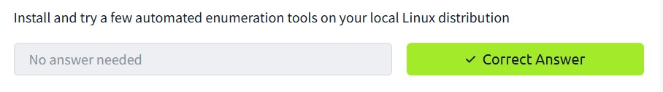

TASK 5 : PRIVILEGE ESCALATION : KERNEL EXPLOITS

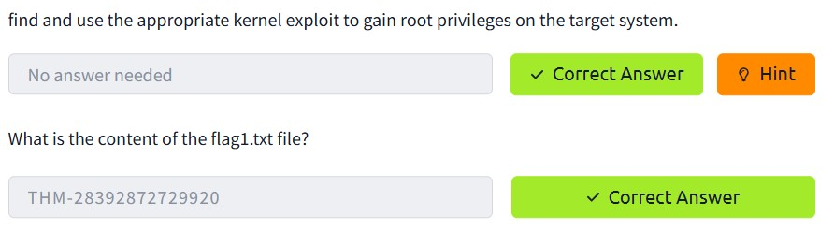

TASK 6 : PRIVILEGE ESCALATION : SUDO

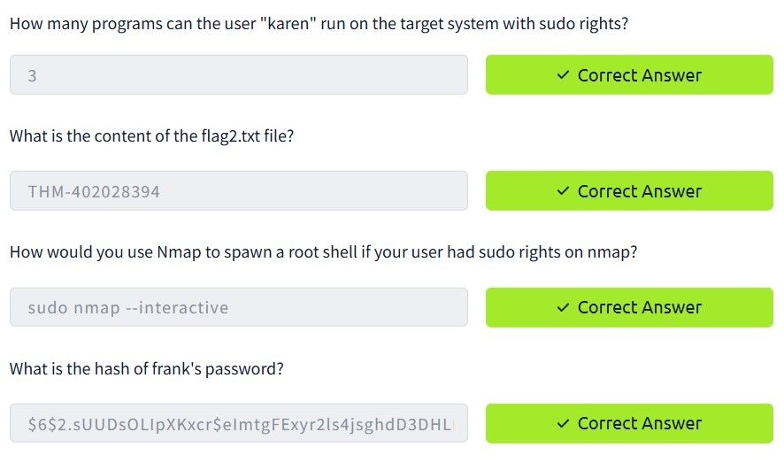

TASK 7 : PRIVILEGE ESCALATION : SUID

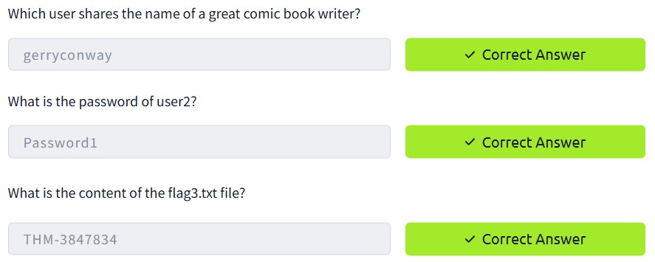

TASK 8 : PRIVILEGE ESCALATION : CAPABILITIES

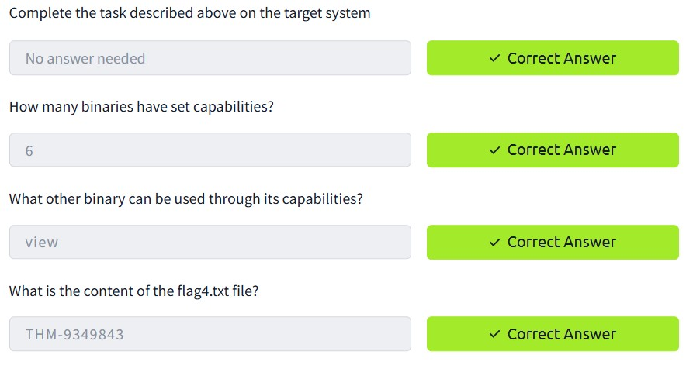

TASK 9 : PRIVILEGE ESCALATION : CRON JOBS

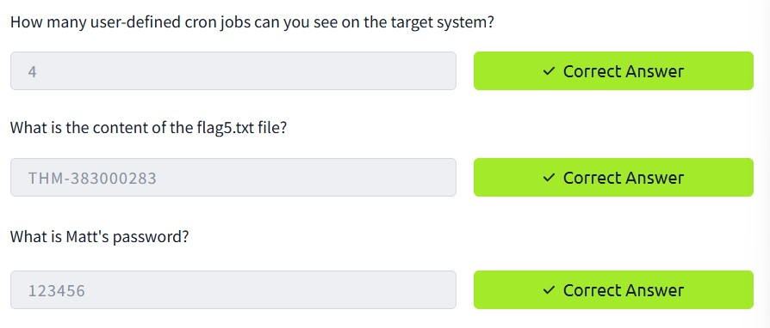

TASK 10 : PRIVILEGE ESCALATION : PATH

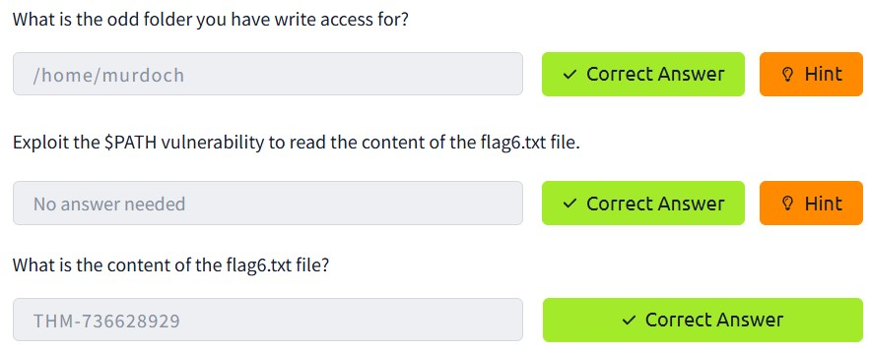

TASK 11 : PRIVILEGE ESCALATION : NFS

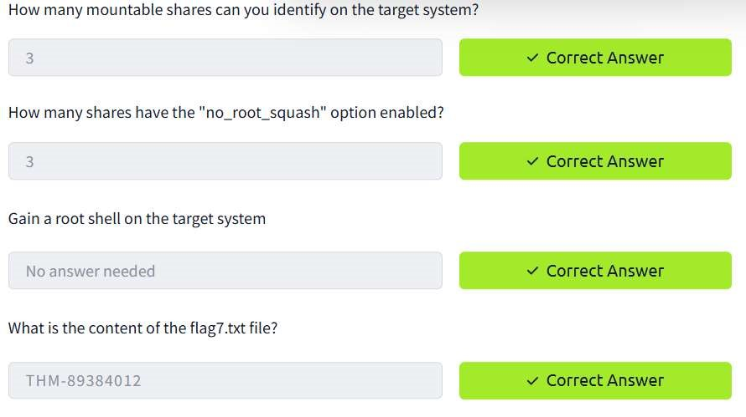

TASK 12 : CAPSTONE CHALLENGE

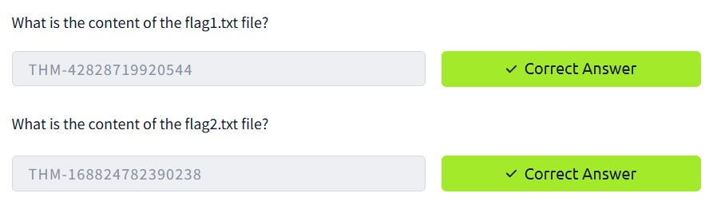

CONCLUSION:

Tryhackme platform demonstrate linux privilege escalation task is successfully executed.